

**Appendix 1 – Site Plan**

**19/00410/FUL – Falcon Rowing Club**

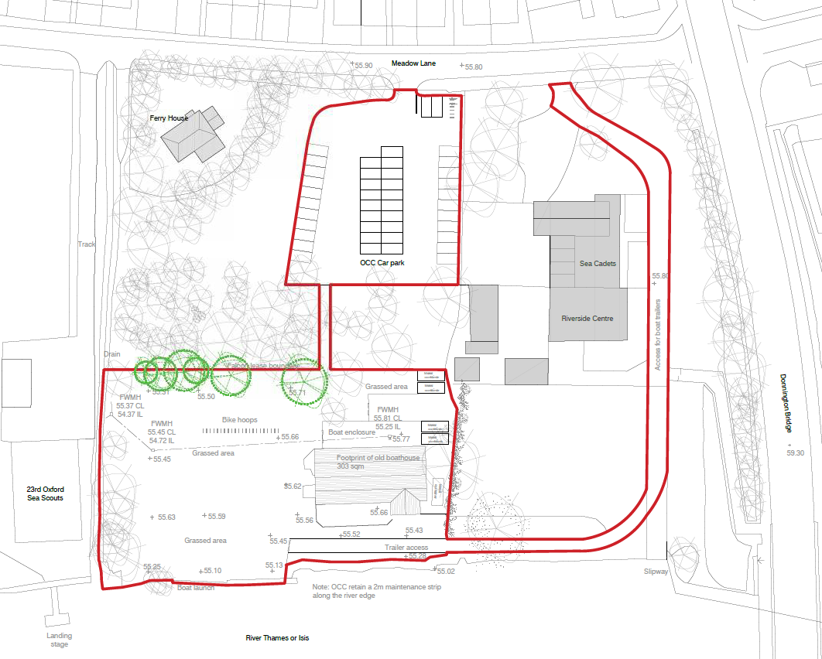

River

Thames

Meadow Lane

Donnington Bridge